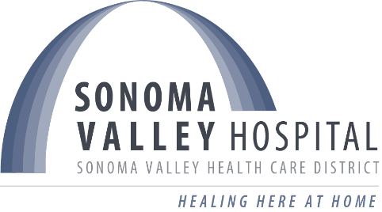 | Sonoma Valley Health Care District  BOARD OF DIRECTORS  CLOSED SESSION AGENDA  thursday, december 4, 2025  Closed Session: 4:30pm – 5:00pm
Held in Person at
Council Chambers
177 First Street West, Sonoma
In compliance with the Americans Disabilities Act, if you require special accommodations to participate in a District meeting, please contact Board Clerk, Whitney Reese at wreese@sonomavalleyhospital.org at least 48 hours prior to the meeting.
AGENDA ITEM
MISSION STATEMENT
The mission of SVHCD is to maintain, improve, and restore the health of everyone in our community.
1. CALL TO ORDER |  | Lee Myatt
2. CLOSED SESSION  Calif. Government Code §37606 and §37624.3: REPORT INVOLVING TRADE SECRET Discussion will concern: new service and/or program |  | Armfield
3. ADJOURN |  | Lee Myatt

